**DSD LAB**

**A PROJECT PROPOSAL ON**

**Finite State Machine For Washing Machine**



Group Members:

Muhammad Umar Jan 21 PWCSE2000

Muhammad Saad 21PWCSE1997

Ayman Maab 21PWCSE2076

Submitted to:

Sir Shahzada Faheem

Department of Computer System Engineering

Project Title: **Finite State Machine For Washing Machine**

**1. Introduction:**

This project proposes the development of a washing machine control system using a Finite State Machine (FSM) approach. The FSM will manage the various stages of a washing cycle, including pre-wash, wash, rinse, spin, and drain, based on user-selected settings.

The project aims to achieve the following objectives:

* Design a robust and efficient FSM for controlling the washing machine's operations.
* Implement the FSM using a microcontroller or programmable logic device.
* Provide a user interface (potentially physical buttons or a digital display) for selecting wash settings and monitoring cycle progress.
* Enhance the washing machine's functionality and user control compared to traditional control methods.

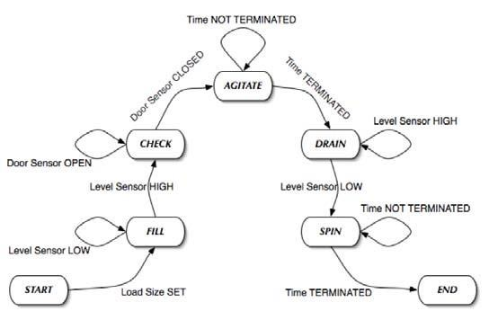

**2. Resources Required:**

The project will require the following resources:

* **Spartan 6** FPGA
* **Xilinx** for writing and synthesizing Verilog code
* **ModelSim** for simulating our design

**3. Methodology:**

The project will follow these steps:

* **FSM Design:** Analyzing the washing machine's operation and defining various states (Idle, Pre-wash, Wash, Rinse, Spin, Drain, etc.) and transitions between them based on user selection.
* **Hardware:** We will be running the FSM on Spartan 6 FPGA.
* **Software Development:** Programming the FSM logic onto the chosen hardware platform. This will involve defining states, transitions, and actions associated with each state.
* **User Interface Design:** We will be using Dip switches and push buttons as our input for this machine.
* **Testing and Simulating:** Testing and simulation will done using ModelSIm software.

**4. Expected Outcomes:**

This project is expected to deliver the following outcomes:

* A fully functional washing machine control system driven by a Finite State Machine.
* Enhanced user control over washing cycles through the user interface.
* Potential for future expansion with new wash cycles or features through FSM modifications.

1. **Conclusion:**

This project offers a valuable opportunity to explore and implement a Finite State Machine in a practical application. The resulting washing machine control system will demonstrate the benefits of FSMs in managing complex systems and provide a user-friendly experience for operating a washing machine.

1. **References:** [**An execution-driven simulation tool for teaching cache memories in introductory computer organization courses**](https://www.researchgate.net/publication/221511976_An_execution-driven_simulation_tool_for_teaching_cache_memories_in_introductory_computer_organization_courses?_tp=eyJjb250ZXh0Ijp7ImZpcnN0UGFnZSI6Il9kaXJlY3QiLCJwYWdlIjoiX2RpcmVjdCJ9fQ) |  [Julio Sahuquillo](https://www.researchgate.net/profile/Julio-Sahuquillo?_tp=eyJjb250ZXh0Ijp7ImZpcnN0UGFnZSI6Il9kaXJlY3QiLCJwYWdlIjoiX2RpcmVjdCJ9fQ)